**Educational and Social Activities**

RSM organizes academic programmes like Seminars, health awareness campaigns and medical camps. Students actively participate in these programmes under the guidance of faculty.  Engaging in these activities provides a safe and jovial environment for students to develop communication, empathy, and teamwork. These activities not only build social skills but also boost confidence, making students feel comfortable and empowered in social situations.

Nursing professionals with a broad range of skills and a proven dedication to their careers are highly valued by healthcare management. Partaking in these activities give opportunity to our students to demonstrate their commitment and willingness to go above and beyond the call of duty. Subsequently, they become more desirable candidates in the competitive job environment. The experiences, particularly leadership roles, and involvement in nursing organizations, unequivocally, makes them stand out. Furthermore their active participation in these activities set them apart and improves their chances of getting the desired position in healthcare industry.

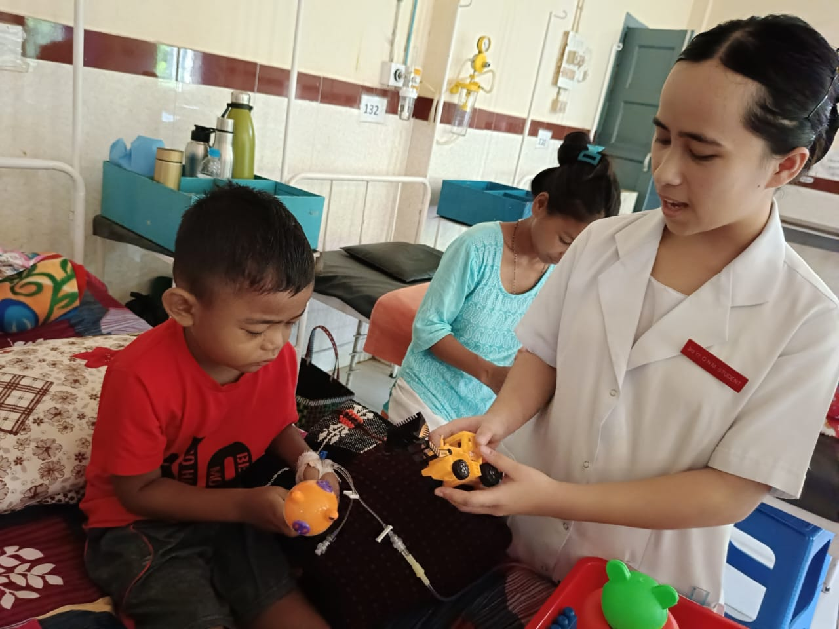

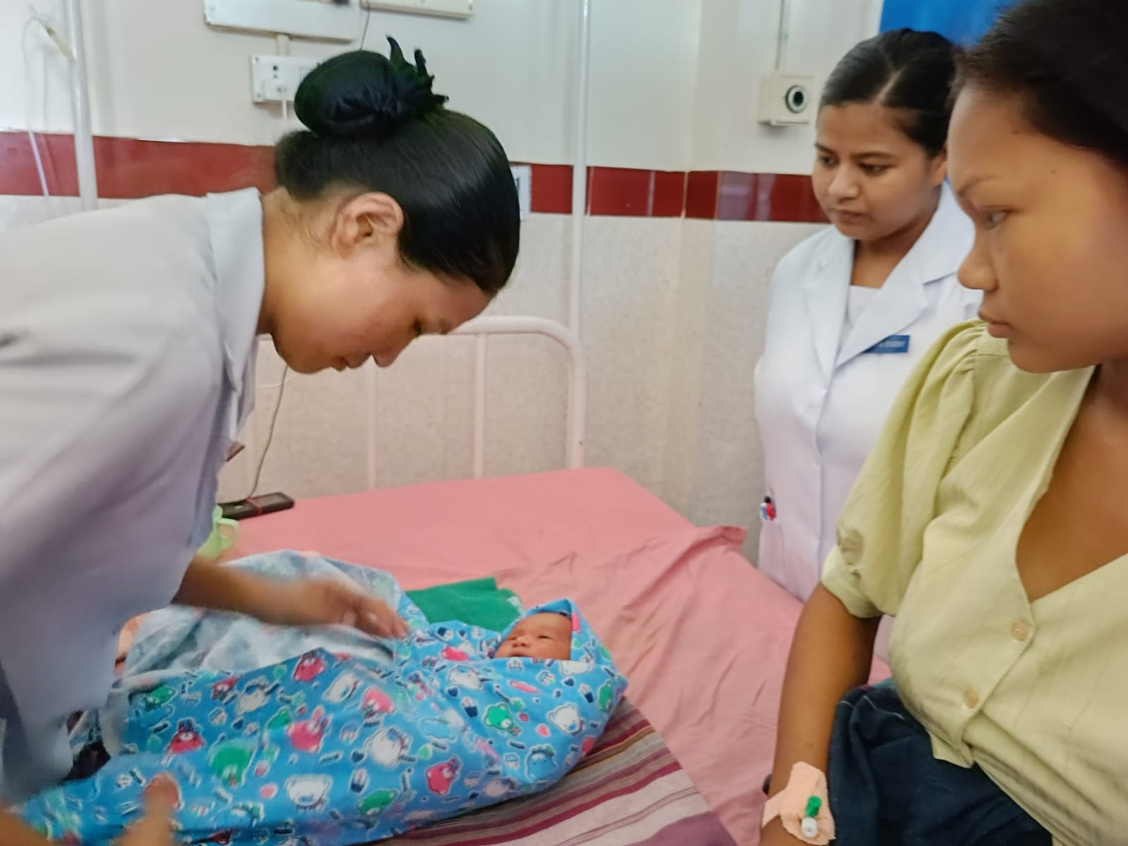

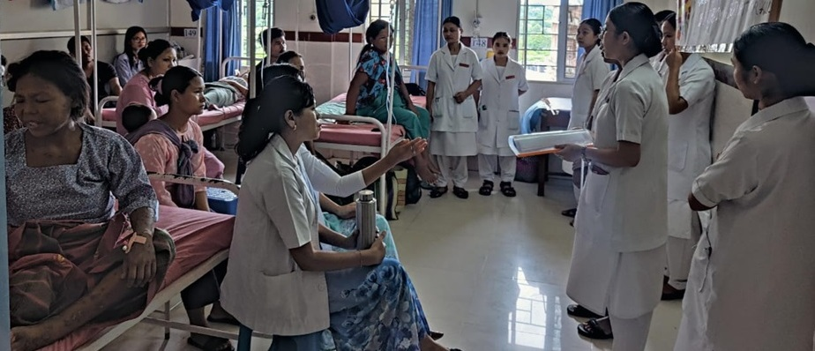

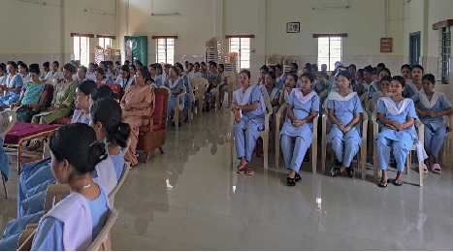

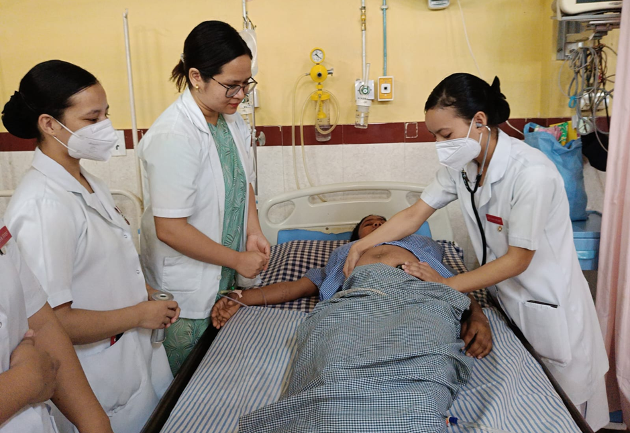

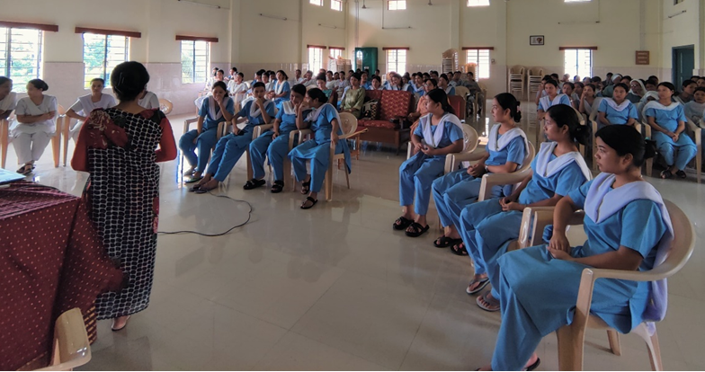

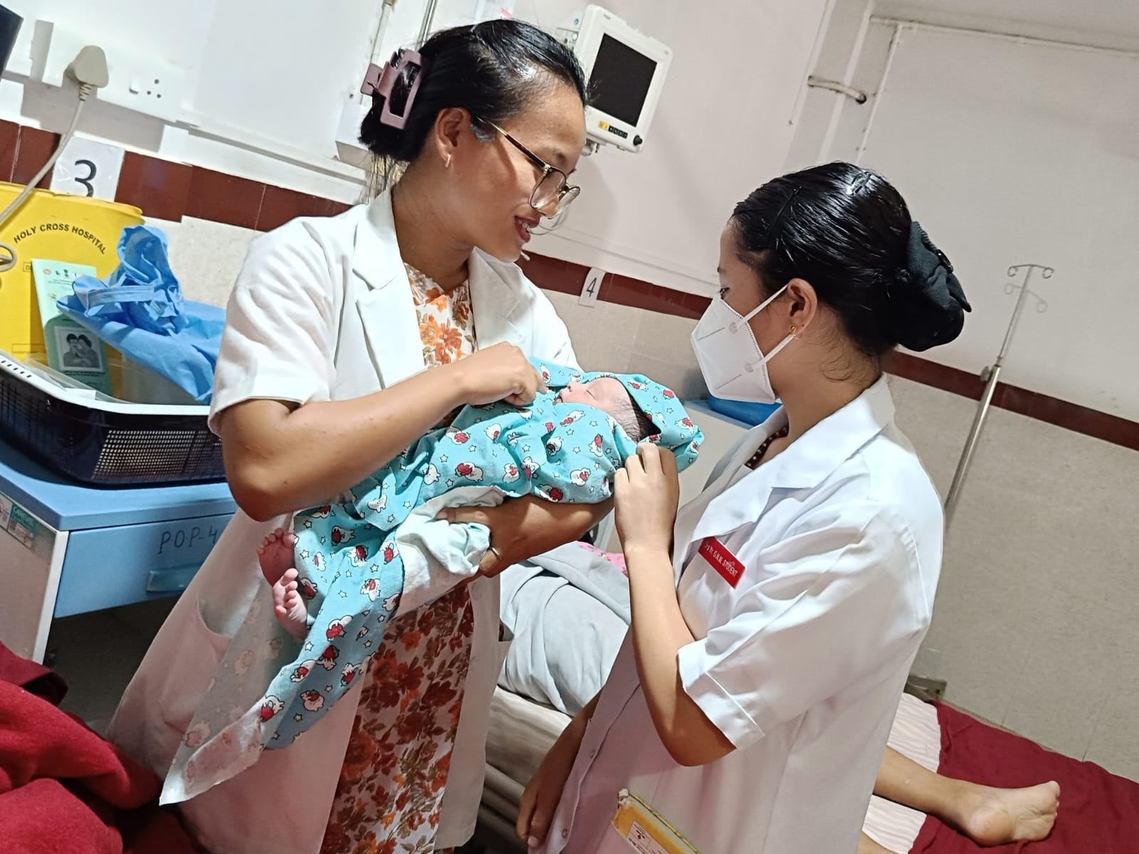

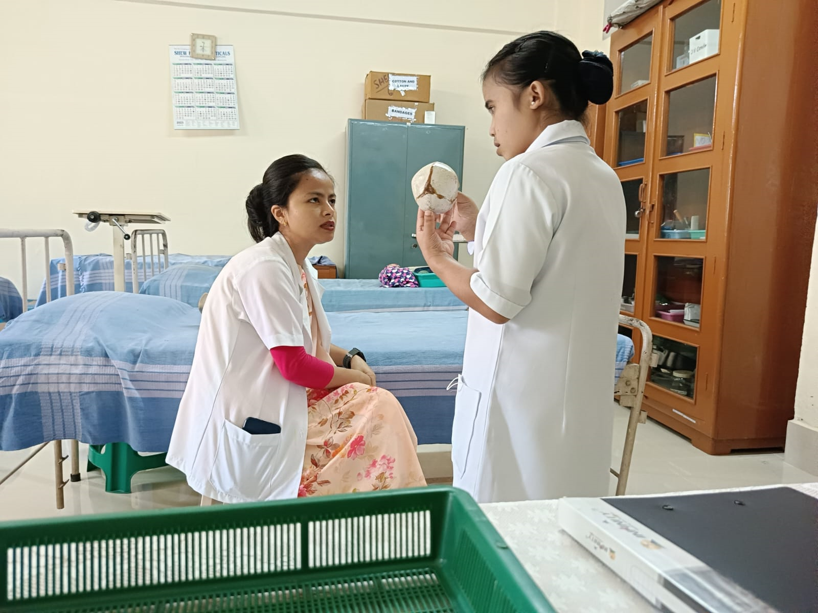

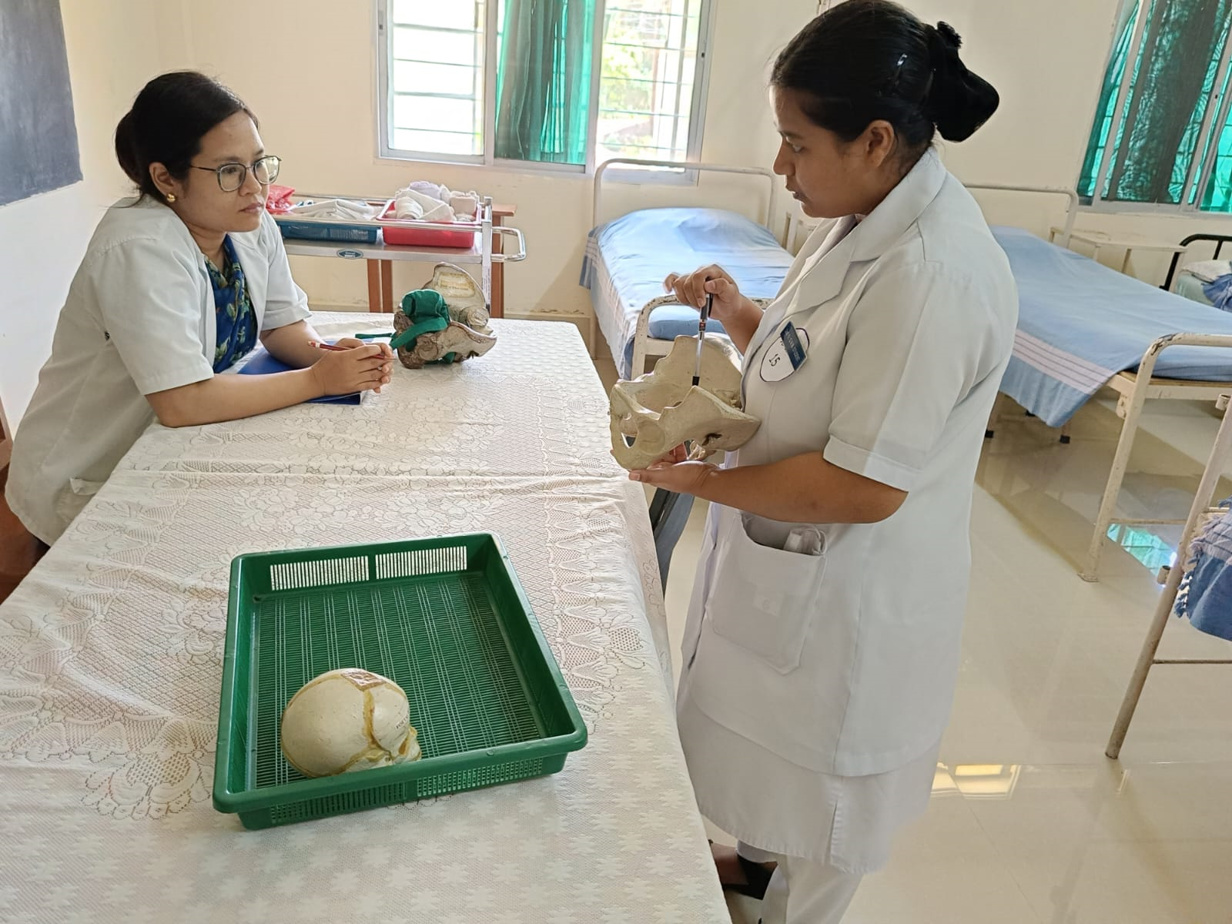

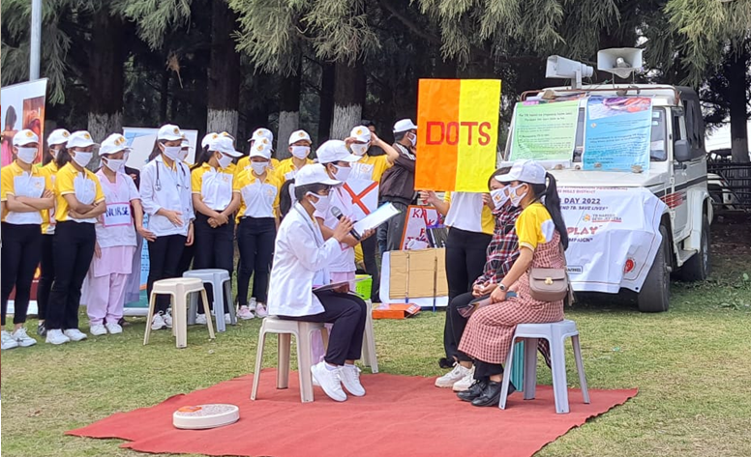

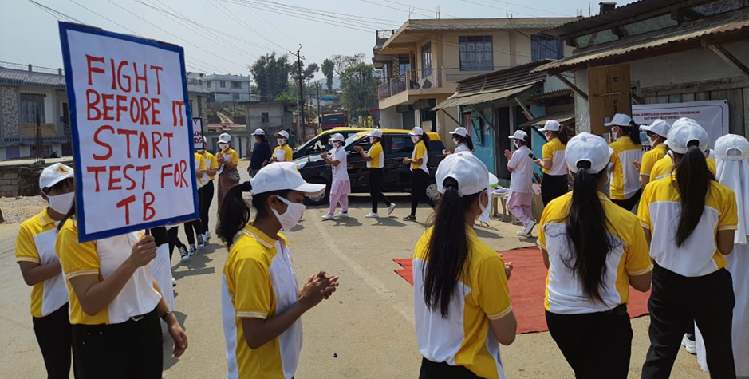

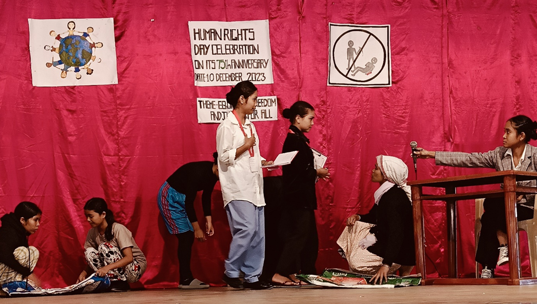

**Cultural Activities**

Students get fairly good opportunity in the school to exhibit their talents through a host of celebrations. They participate in various cultural activities which are organized to cater to the all round development of personality. Inter school sport competitions and cultural competitions are organized by Trained Nurses Association of India (TNAI) in Shillong in which students participate and develop a sense of confidence and achievement. Our school hosts annual cultural festivals that celebrate the rich diversity of our heritage and values, showcasing traditional music, dance, cuisine, and art forms from various regions. These festivals provide students with opportunities to learn about different cultures, connect with peers from diverse backgrounds, and foster a sense of unity and inclusivity.

The school encourages student participation in sports tournaments, talent shows, and charity fundraisers, fostering a spirit of camaraderie, teamwork, and leadership among students. Through our diverse array of events and cultural programs, we strive to create a dynamic and inclusive campus environment that promotes personal growth, cultural appreciation, and academic excellence. These events play a vital role in enhancing the overall student experience and shaping well-rounded healthcare professionals who are equipped to make meaningful contributions to society.

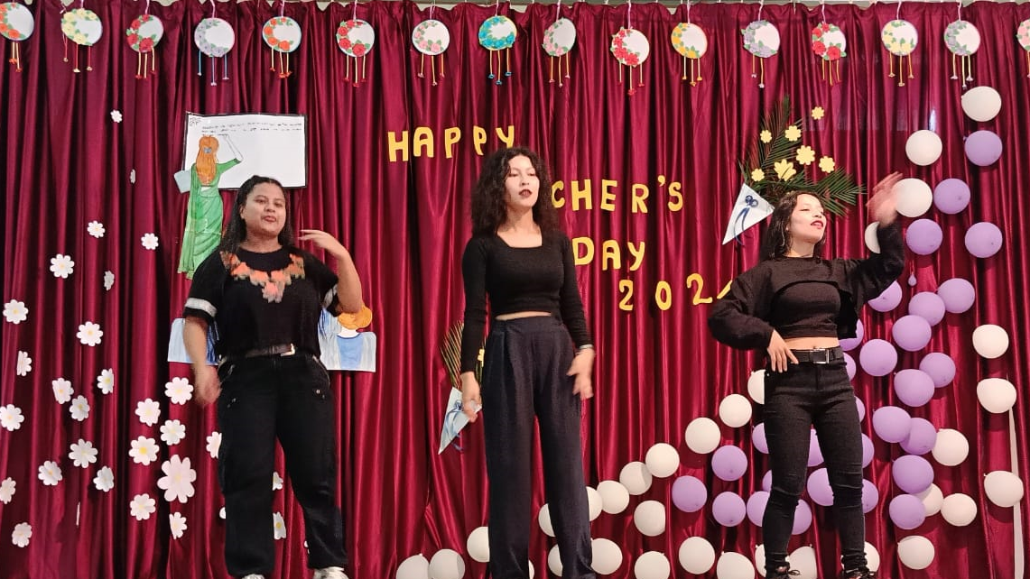

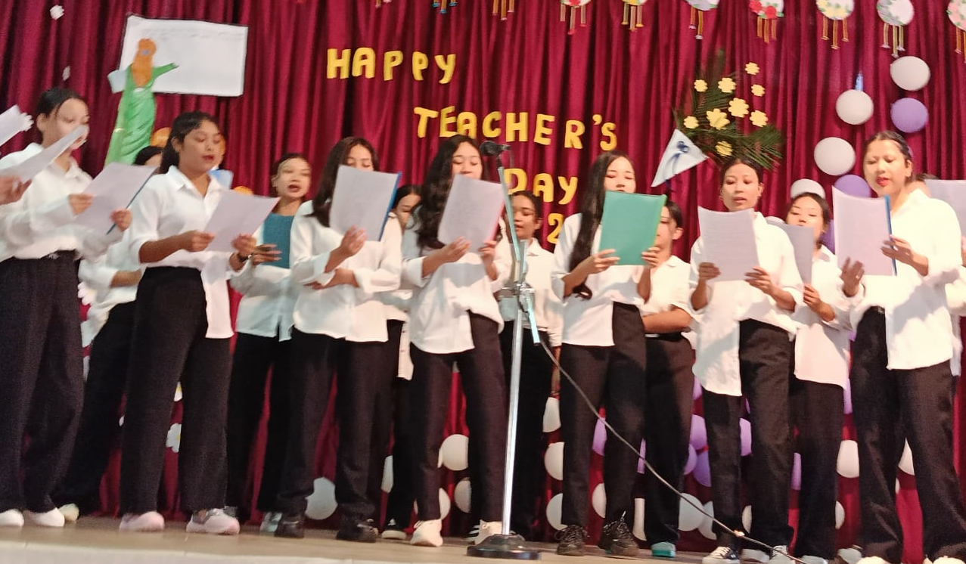

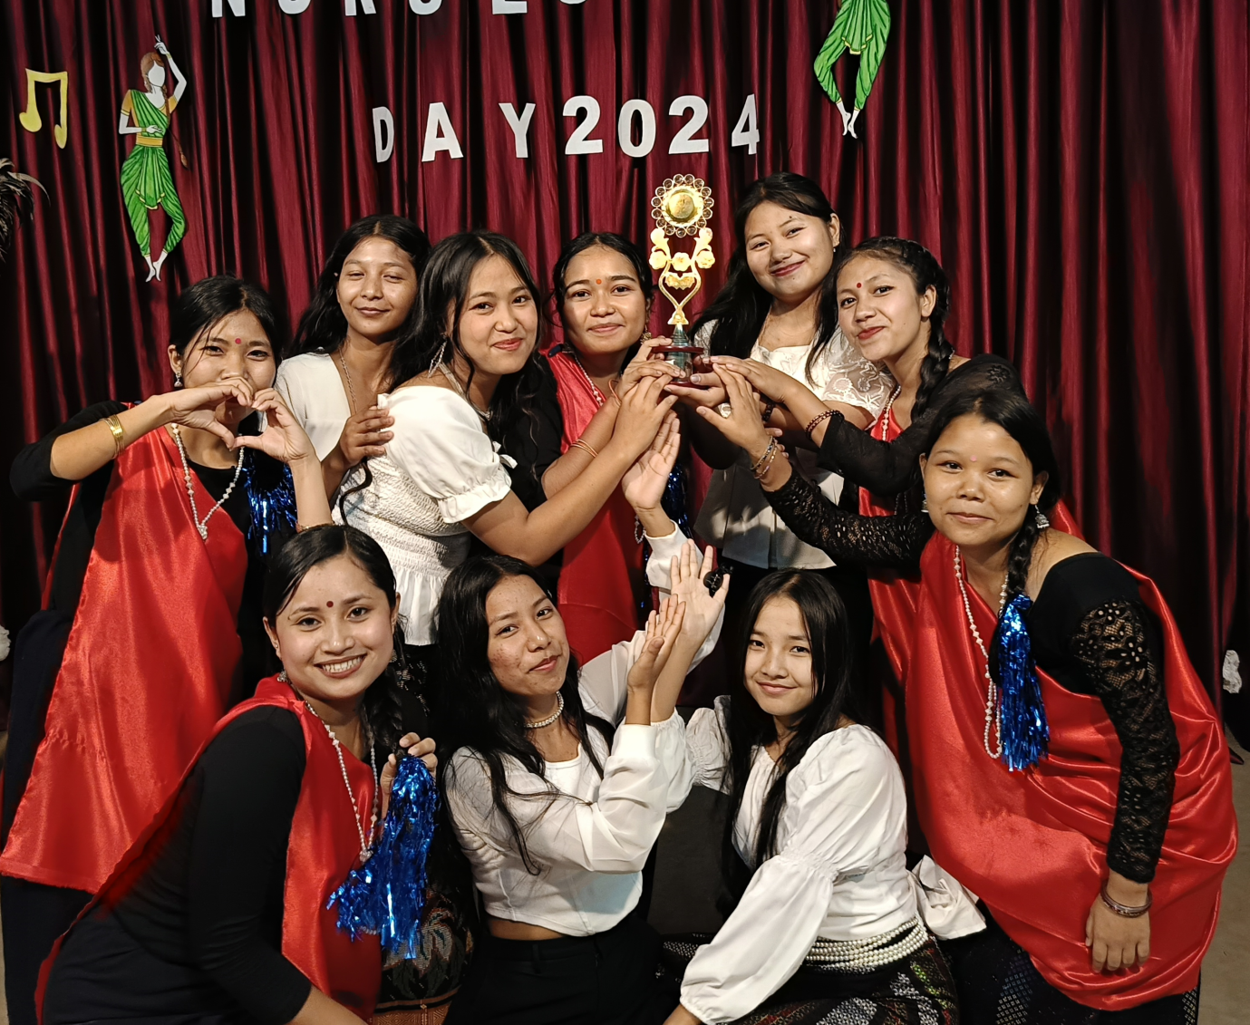

**Annual Sports Meet**

**Physical fitness is not only one of the most important keys to a healthy body; it is the basis of dynamic and creative intellectual activity**

*John F. Kennedy*

Sports develop a sense of friendliness among the children and boost up their team spirit. It rather helps to develop mental and physical toughness in them. Our Annual Sports meet commences with great enthusiasm and excitement. Arrangements start weeks prior to the actual event with students practicing during school hours. Faculties ensure 100% participation of the students.

Sports meet at RSM marks a celebration of the spirit of sportsmanship, teamwork, and healthy competition. This event is not just about winning or losing, but giving our best, pushing limits, and embracing the values that sports teach us, namely discipline, perseverance, and respect.

The Sports meet is a platform for each one of our students to showcase their talents, to cheer for friends, and craft everlasting memories. They compete with fairness, support each other with enthusiasm, and have cherishing fun time.

